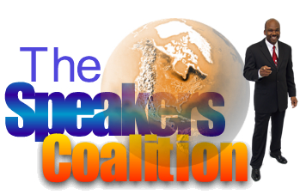
Dwayne G. Smith, DTM
Toastmasters International’s 2002 World Champion of Public Speaking
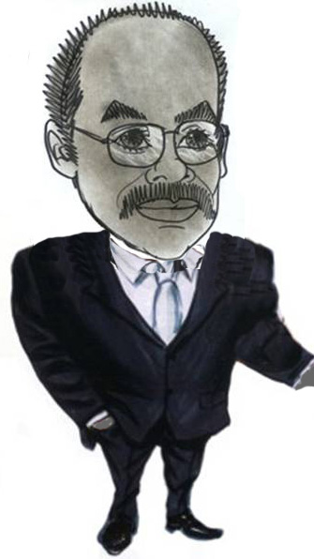
After having won that designation, Dwayne has made it his business to help others to become winners in this wonderful life. He is deeply inspired by the belief that people have the ability to do almost anything they think they cannot do.
Dwayne is probably one of the unlikeliest persons to win a public speaking title. He had no experience or desire for public speaking before joining Toastmasters, and his work in Information Technology required very little oral communication, except for yelling at malfunctioning computers.

He has given keynote speeches and lead training seminars in the U.S. and internationally. If you are part of an organization in need of a competent speaker, please visit www.dwaynegsmith.com for additional information

Dwayne is the author of two books, his most recent being “A World Apart: From Quiet and Shy To World Champion Speaker”.

District 67 Toastmasters, let’s welcome Dwayne G. Smith.

www.DwayneGSmith.com
770.467.0324

