+++
CAN ENJOY
Breakfast + 2.5 hours Q & A
About public speaking, writing books,
Or becoming a professional speaker
Each minute only costs NT$6.0000000000

A breakfast and Q&A session - “Up close and personal with the Pro.”

Date: April 27th, 2008, Sunday morning (Early Morning 7:00 – 9:30 am)
Venue: 日安_KAFFA北市南京東路三段303巷24號(地下樓)
王朝大酒店 (原環亞飯店) 後2分鐘路程
This 2.5 hour breakfast session is an unscripted, un-rehearsed, live question and answer session with one of the most successful professional products of Toastmasters International.
Anything goes and this is your chance to ask anything you want about The World Championship of: ․ Public speaking
․ Writing books or
․ Becoming a professional speaker
Seats are limited to 60. Download Registration Form At: http://nccu.edu.tw/93305064/TrainingCamp_RegistrationForm.doc
Contact : trainingCamp0425_08@yahoogroups.com
Ichi Su 0911739279, Kelly Yang 0936156387
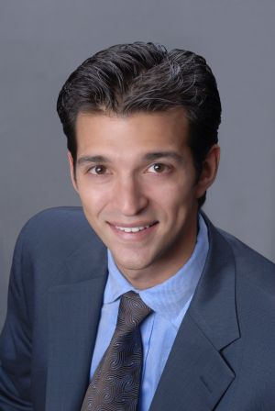
Trainer’s Information: Rory Vaden, MBA
˙ Toastmasters 2007 World Champion of Public Speaking
1st Runner Up.
˙ Co-Founder of a multi-million dollar speaking and
training company - Success Starts Now!™. It puts on
multi-thousand person motivational sales training
conferences all across the country.
˙ The author of “No Laughs to Know Laughs – How To Be
Funny To Make More Money” and the new book
“Influencing an audience of 1 or 1000 – Time Saving Techniques for Creating
Compelling Presentations.”

