
2010 Division H Contest
Humorous Speech & Evaluation Contests
District 67, Toastmasters International
Soar to a New Height!
 | Date: | Oct. 30th (Saturday), 2010 |  |  |  |  | 日期：2010年10月30日（星期六）
 | Time: | 13:30~16:30 |  |  |  |  | 時間：下午1點30分至4點30分
 | Venue: | No.40, Sec. 3, Zhongshan N. Rd., Zhongshan Dist., Taipei City Tatung University Shan-Chih Hall B205 |  |  |  |  | 地點：台北市中山區中山北路三段四十號大同大學尚志教育會館 B205 (校園正門白色歐式建築地下2樓)
Time |  |  | Program
13:30-13:58 |  |  | Reception/Registration |  |  |  |  |  |  |  | Receptionists
13:58-14:00 |  |  | Contestants draw to order (Speech Contest) |  |  |  |  |  |  |  | SAA
14:00-14:01 |  |  | Call Meeting to Order/ SAA |  |  |  |  |  |  |  | SAA
14:01-14:05 |  |  | Words of Welcome – Division H Governor |  |  |  |  |  |  |  | Tim Wang
14:05-14:10 |  |  | Opening Remarks of Contest Chair / Presenting Timer, Vote Counter, SAA |  |  |  |  |  |  |  | Contest Chair – Wini Kao, ACS, AL
14:10-14:15 |  |  | Chief Judge Briefing |  |  |  |  |  |  |  | Chief Judge

Humorous Speech Contest
14:15-15:10 |  |  |  | Order |  | Speech Title |  |  |  | Contestants
5’~7’ each  *1-minute silence between each contestant |  |  |  |  |  | Culture Clash |  |  |  | Erin Ke
 |  |  |  |  |  | Till death do us part" |  |  |  | Caroline Kiang
 |  |  |  |  |  | Golden Prize |  |  |  | Sean Yang
 |  |  |  |  |  | Clean It Up |  |  |  | Joyce Lee
 |  |  |  |  |  | A new dimension of Toastmasters club |  |  |  | Jennifer Chang
 |  |  |  |  |  | Chasing a man |  |  |  | Nai-Ling Liu
15:10-15:25 |  |  |  | Intermission and Evaluation Contest Speaking Order Drawing

Evaluation Contest
15:25-15:27 |  |  |  | Call Meeting to Order / SAA |  |  |  |  |  | SAA
15:27-15:30 |  |  |  | Contest Chair |  |  |  |  |  | Contest Chair
15:30-15:35 |  |  |  | Chief Judge Briefing |  |  |  |  |  | Chief Judge
15:35-15:42 |  |  |  | Target Speech |  |  |  |  |  | Test Speaker
15:47-16:15 |  |  |  | Contestants
1’~2’ each  *1-minute silence between each contestant |  |  |  |  | Sean Yang |  |  |  | Caroline Kiang
 |  |  |  |  | Amanda Hu |  |  |  | Emily Chen
 |  |  |  |  | Victor Chu |  |  |  | Justin Liu
16:15-16:25 |  |  |  | Certificates / Appreciation / Awards Presentation |  |  |  |  |  | Tim Wang
16:25-16:35 |  |  |  | Closing remark |  |  |  |  |  | Tim Wang

Contest Adjourned

Warmly Welcome you to join us!!

【Tatung University Shan-Chih Hall B205】
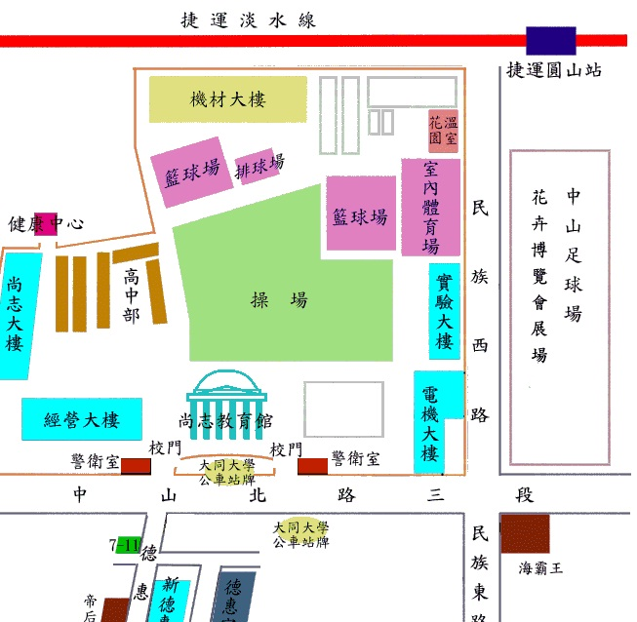
Public Transportation Info
※ Check out in GoogleMap: (http://bit.ly/cn3n1L)
Bus lines公車路線：
(1) Departing from Taipei Railway Station由台北火車站出發：
可由北一門(鄭州路)搭乘公車218、220、260、310或台北大眾捷運台北車站6D出口處搭乘247或287線 至大同大學站下車。
(2) Departing from Neihu, Shilin由內湖、士林方向出發：
Take bus line 218, 260, 310, 220, 247 or 287, disembark at TATUNG University(大同大學站) station.
MRT捷運路線：
Take MRT Red line to YuanShan station, walk toward ZhongShang N. rd for about 10 min.
可搭乘淡水-新店線或北投-南勢角線到圓山站下車，步行往中山北路方向約十分鐘。

Upcoming Events
【2010 Fall Conference in Tainan】
Time: November 20-21
Venue: Shangri-La's Far Eastern Plaza Hotel
Official webpage:
http://www.toastmasters.org.tw/clubs/alemax/2010fallcon/ch/index.htm
