2011 Division D & K Manual Training
☆Date：March 12th, 2011 (Saturday) 3月12日(週六)
☆Time：13:30-17:00 下午13點30分至下午17點
☆Venue：台電南科超高壓變電所 C棟二樓會議室
☆Address：台南市善化區南科北路11號
(No.11, Nanke N. Rd., Shanhua Dist., Tainan City 741, Taiwan (R.O.C.))
☆Participants: Division K & D members are welcomed
☆Language: Mandarin & English
Agenda
Time | Schedule | Master
13:00-13:30 | Reception | Camila , Susan Su , Chin Chi, Karl
13:30-13:31 | Call the Training to order  Timer: Judy Lin SAA:Gina Wu | TBA
13:31-13:40 | Welcome & Greeting | Jeffrey Huang, Tim Wu
13:40-14:10 | CL Manual | Grace Shih
14:10-14:40 | Speechcraft Manual | Jeffrey Huang
14:40-15:10 | Refreshment & Take a break | Shin Ying Toastmasters Club
15:10-15:40 | Youth leadership Manual | Melody Tu
15:40-16:10 | Introduce 15 advanced commnicaiton Manuals | Grace Shih
16:10-16:50  (Each discussion session:20’) | Discussion Group:  (Members could choose any 2 of 4 programes to join discussion group)  1.Humorously Speaking  2.Public Relations  3.Storytelling  4.Special Occasion Speeches | Doris Kuo  Tim Wu  Dinger Chen  Sophie Yang
16:50-17:00 | Award Presentation | Tim Wu, Jeffrey Huang
Note:

☆Venue：台電南科超高壓變電所 C棟二樓會議室
☆Address：台南市善化區南科北路11號
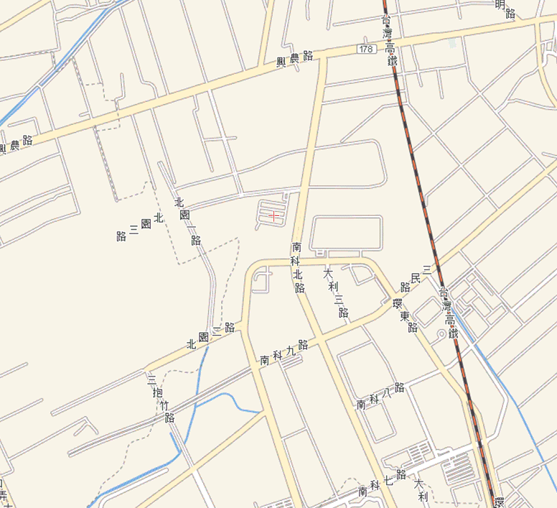
No.11, Nanke N. Rd., Shanhua Dist., Tainan City 741, Taiwan (R.O.C.)
台南市善化區南科北路11號

