How to assign Proxy for International Convention election and voting
如何處理世界年會的選舉和投票委託書
- Each club has two votes, but only need one proxy 每個分會有兩票，但只需要一個委託書
- Only Club President “or” club secretary can do the proxy assignment. (one person needs to do the proxy for two votes.) 只有分會會長”或”分會秘書長有權利來指定該分會的委託書 (其中一位處理即可，不必兩人都做)
- Log in on Toastmasters International website 請登入世界總會網站: www.toastmasters.org
- From “Leadership Central”, choose “Club Central” , then click the club name beneath that you are a club president or secretary
由 Leadership Central 進入 Club 並點選下方你擔任會長或秘書長的分會名字

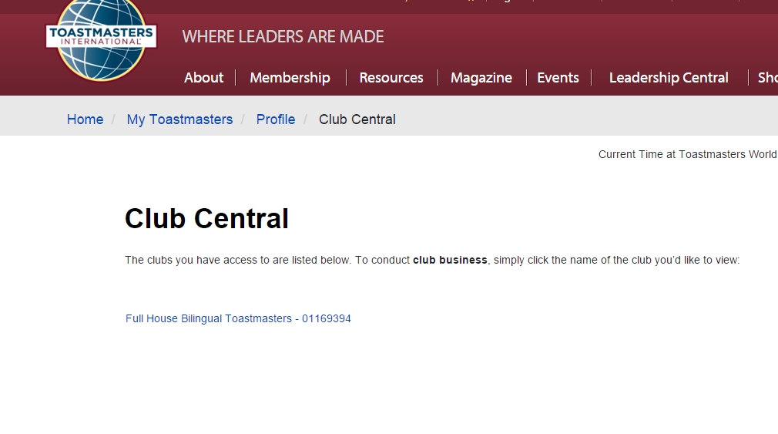
- Click “Assign/Delegat International Election Club Proxy” as below circled for next step 點選 下方打圈的選項，進行下一步

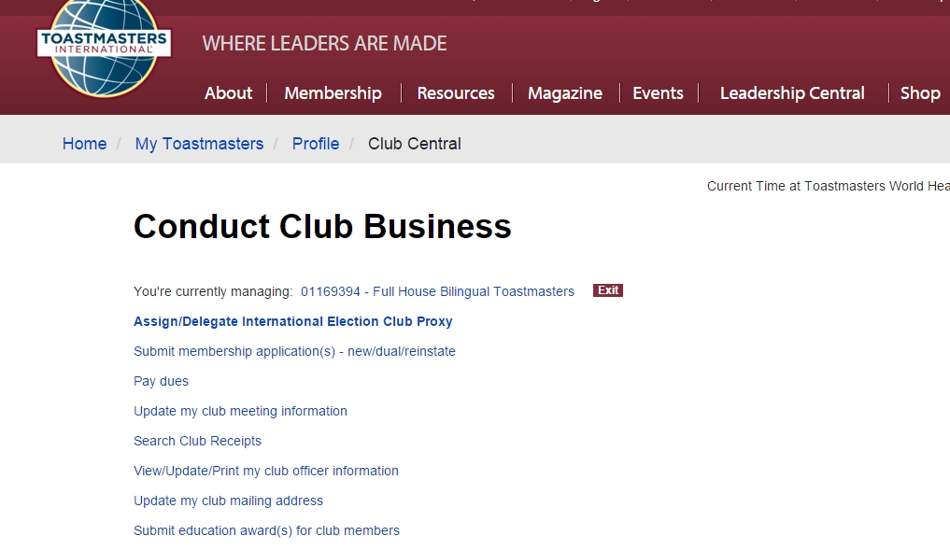

- Click “Designate District Director” (meaning your club assign the proxy to the 2016-2017 District Director to vote for your club)
點選下方打圈的選項 ( 表示你的分會將委託書賦予總會長代替分會行使投票權)

PS. If your club has a club delegate to attend the International Convention, you can also assign your club proxy to him/her by choosing the below “left” (Send a club delegate). You club can also assign the proxy to another active member from other club to cast the votest. Then choose the one on the “right” (designate active Toastmaster)
註: 若您的分會有代表參加世界年會，你也可將投票權委託給該會員，請選下方左邊”send a club delegate”. 或是也可指派其他分會的有效會員替你分會投票，那請選右方” designate active Toastmaster)

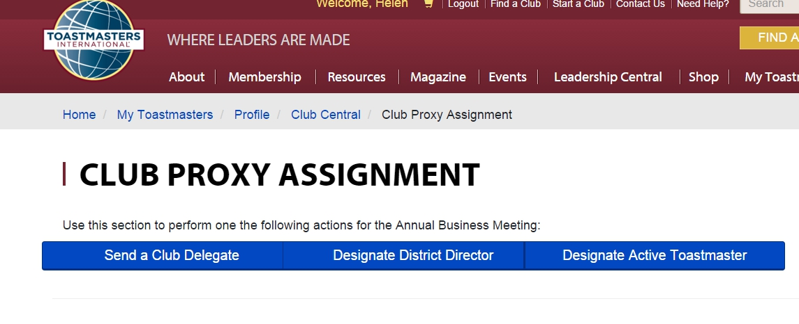

- Then browse to the bottom of the page (no need to click or fill in any item in the middle of the page), then type your name , then press “Submit”
不必在該網頁填寫任何選項或資料，只需到該頁最下方，打入你的英文姓名(當成電子簽名)，然後點選下方的 Submit (呈送)

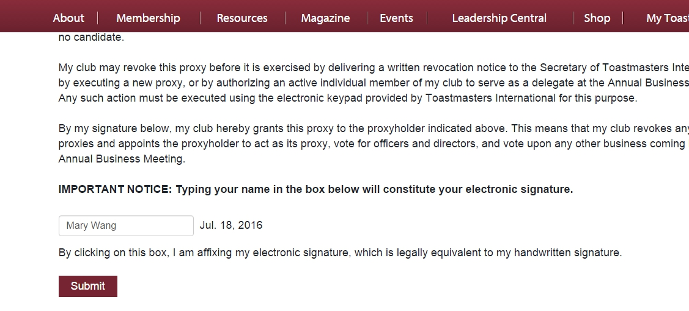
Type your name here
請在這打入你英文名
點這裡呈送

- This page shows your submission result. It’s done ! 這頁(打圈處的字)表示你呈送的資料內容，你已成功指派分會投票權的委託書給總會長。

